### **Project 8：Fan Module**

**Description**

The L9110 fan module adopts L9110 motor control chip, it can control the rotation direction and speed of the motor. Moreover, this module is efficient and with high quality fan, which can put out the flame within 20cm distance. Similarly, it is an important part of fire robot as well.

**Specifications:**

* Fan diameter: 75mm
* Working voltage: 5V

**Equipment：**

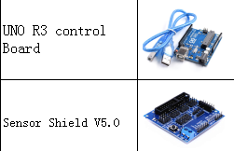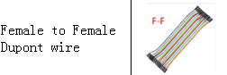

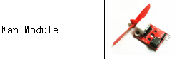

**Connection Diagram：**

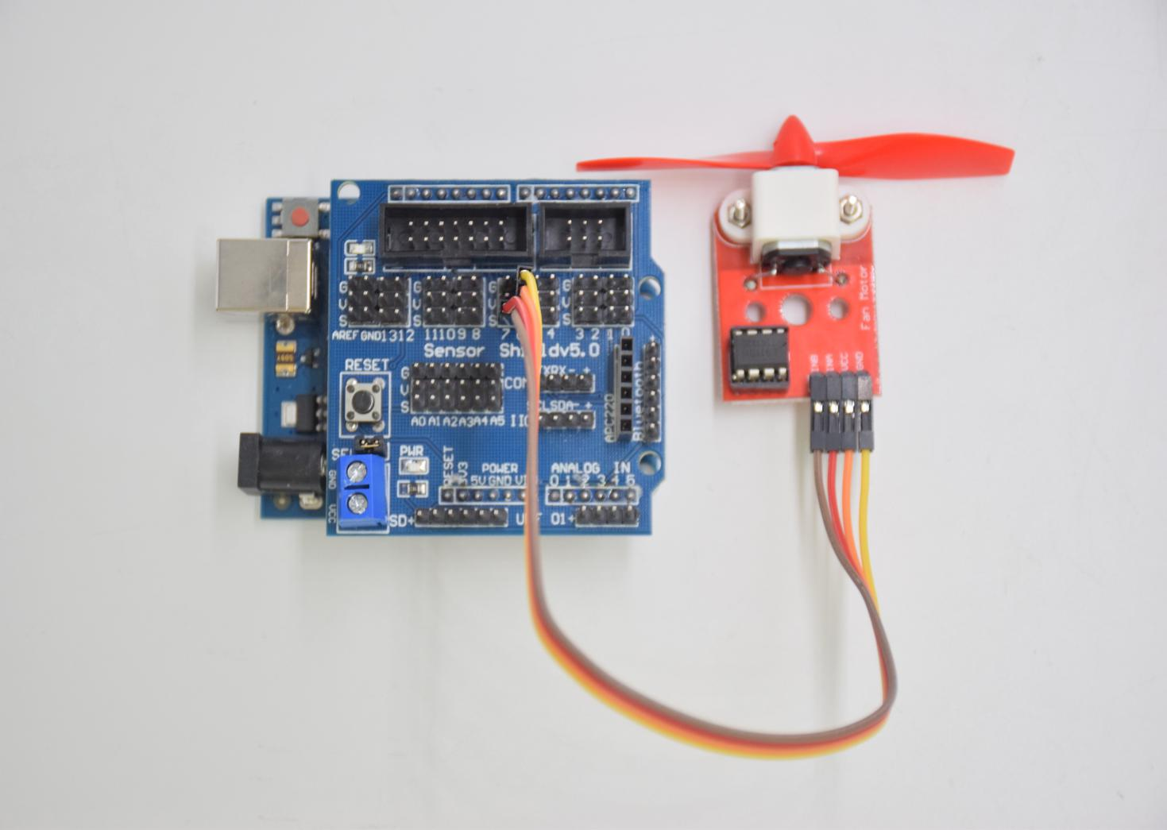

Motor fan module

INB -- D6

INA -- D7

VCC -- 5V

GND -- GND

**Test Code：**

**void setup () {**

**pinMode (7, OUTPUT); //define D7 pin as output**

**pinMode (6, OUTPUT); //define D6 pin as output**

**}**

**void loop () {**

**digitalWrite (7, LOW);**

**digitalWrite (6, HIGH); // Reverse rotation of the motor**

**delay (3000); // delay 3S**

**digitalWrite (7, LOW);**

**digitalWrite (6, LOW); // The motor stops rotating**

**delay (1000); //delay 1S**

**digitalWrite (7, HIGH);**

**digitalWrite (6, LOW); // The motor rotates in the forward direction**

**delay (3000); // delay 3S**

**}**

**Test Result：**

Upload test code, wire according to connection diagram, the DIP switch is dialed to right side and power on. The fan rotates counterclockwise for 3000ms, stops for 1000ms, then rotates clockwise for 3000ms.